System Architecture Document
  - AutoRef Project
Date |  |  |  | Version
February 5 2024 |  | ​ |  | 1
Mathematics and Computer Science
Mechatronic Systems Design EngD
www.tue.nl
Author
MSD 2023
​

Client
René van de Molengraft, Erjen Lefeber

​

Contents
1 ‎Introduction 3
1.1 Goal 3
1.1.1 Project Context 3
1.1.2 Previous Works 3
1.1.3 RoboCup Middle Size League (MSL) Rules 3
2 System Thinking Processes 4
2.1 Needs and Missions 4
2.2 Requirements and Use Cases 4
2.3 System Architectural Diagram 6
2.4 Validation 6
2.5 Risk Management 6
2.6 Feasibility Study 6
2.7 Development Approach 7
2.8 Work Breakdown Structure 7
References 8
An example of a section heade 8
An example of a subsection header 8
An example of a section header 9
Example of a section header above a table 9

​

‎Introduction
Starting from 2015, MSD EngD has been assigned to Autonomous Referee Project as the 1st in-house project. Most of the stakeholders’ needs remained the same, and MSD 2023 oversaw this project in 2024.

Goal
The end-goal of the project is to create a fully autonomous referee for the RoboCup Middle Size League soccer match replacing human referee when sensing and making decision. Since all of the previous team have not been able to create a fully autonomous referee, the stakeholders’ minimum goal was to add something new or to improve the previous system. Therefore, the goal for this project is limited to the partial development of the fully autonomous referee in which improvements can be made upon.

Project Context
The developed system will be tested using Tech United soccer robots (TURTLE). It should be able to create logs and show evidence if needed. Furthermore, the project should be built on the earlier work and should have a structure to make it possible for future generations to work on. To achieve this, clear documentation including the earlier work process should be included. To avoid any misperception, the general expected systems (needs) were listed below:

- The AutoRef should be fast and accurate when making decisions.
- The system can communicate the decisions to teams, human referee, and viewers.
- It can be applied on RoboCup competition with at least using TURTLE and MSL field.
- A validation method should be presented and used.
- The system should have logs of the match and can show evidence of violations when needed.

Additionally, the stakeholders wants were:
- The project should build on the work of the previous years.
- Deliverables: presentation (include demonstration) and documentation.
- Personal goals of the team members should be achieved during the process.
- Proper documentation should be provided.

Previous Works
The summary of the previous works has been documented in Summary of Previous Batches (2015-2022). To understand what the previous works has achieved, it was much easier to read the provided document rather than looking back on their repositories.

RoboCup Middle Size League (MSL) Rules
RoboCup MSL rules were quite complicated. This document used 2024 RoboCup MSL rulebook v25.0. The general rule was to use FIFA (Fédération Internationale de Football Association) rules, but since the soccer game context had differences, the rules were modified into RoboCup Changes and Comments. In short, the order of the rules from the highest prioritized to lowest were the Competition Laws, RoboCup Changes and Comments, and FIFA rules. To simplify, an Excel file to summarize some of the rules has been made and it can be found here.

System Thinking Processes

Needs and Missions
Needs:
- Communicability (Capable to show proof, sending decisions)
- Objectivity (Fairness related, the system is impartial):
- Precision and Accuracy at least as good as human
- Robustness:
- Real-time (decision taken at the instant of the actual incident with minimal delay)
- Adaptability
- Need to follow RoboCup MSL Rules
- Safety

Mission:
- To observe the match and make autonomous, unbiased decisions based on the soccer robot rules that can be communicated to teams and viewers.

Requirements and Use Cases
Super System | Human referee, Tech United, RoboCup teams, TURTLE, Audience, RefBox | Human referee, Tech United, RoboCup teams, TURTLE, Tech United field | Tech United, RoboCup teams, TURTLE, Refbox, Audience
System | Ball Out of Play, 0.5 meters free roll,  robot and ball positions (TURTLE), Replay moments | Corner Kick Rules (partial) | Autonomous referee
Sub-system | TURTLE’s Data, Tech United soccer field, MATLAB custom functions, Camera, Drone, Computer | Cameras, YOLOv5, bird’s eye transformation, Computer | Sensors, Actuation (communication protocols), Software (vision processing, decision-making module), Computer, Display Hardware
 | Past | Present | Future
New Functions àSub-systemàTechnical RequirementsßVerification
Proposed Assistant Referee (AR) for RoboCup competition:
- Decide which team is the last one to touch the ball at the current time.
  - Reason: Challenging in terms of implementation with accuracy better than human, can change game outcomes, request by referee (Danny Hameeteman) to avoid subjectivity
- Decide if the ball is out of field.
  - Reason: Common occurrences in match, for better implementation of the last touch function
- Communicate the decision to referee.
  - Reason: To give more information from the AR to referee for better judgement.
Functional requirements of the proposed AR with its specification:
- AR can make combined decision (out of field and last touch) on real-time (when an event occured within 1 seconds).
  - Reason: Based on discussion with Tech United and previous project requirement.
- AR can distinguish which team touched the ball the last time when the whole ball is out of field with desired accuracy at least as good as human, 70% correct decision.
  - Reason: Since AR needs to help the referee, it must be at least as good as human.
  - Reference: (55% to 85% accurate on average for a match, Brazilian referees by De Oliveira et all (2011), Physical Performance and Decision Making in Association Football Referees: A Naturalistic Study)
- AR must have at max distance error between ball and line of ±1.5 cm.
  - Reason: Since the RoboCup rule is based on FIFA, the acceptance accuracy from FIFA using Goal-Line Technology was ±1.5 cm.
  - Reference: Goal-Line Technology testing manual 2020
- AR must ensure operational time of 2 hours.
  - Reason: Based on Goal-Line Technology which has safety factor of 4 (6 hours operational time with 1.5 hours playing time) and RoboCup MSL playing time of 0.5 hour, the required operational time was 4*0.5 = 2 hours
- AR must receive data from independent sensor (not from any sensor in competing team robots)
  - Reason: To avoid any bias in decision making.
- AR must be able to record the received data with timestamp.
  - Reason: For transparency purpose (necessary article to be used as proof), and improvement in better algorithm
- AR must be able to communicate its decision process when needed.
  - Reason: For transparency purpose (necessary article to be used as proof), and improvement in better algorithm

System Architectural Diagram
System Context Diagram:
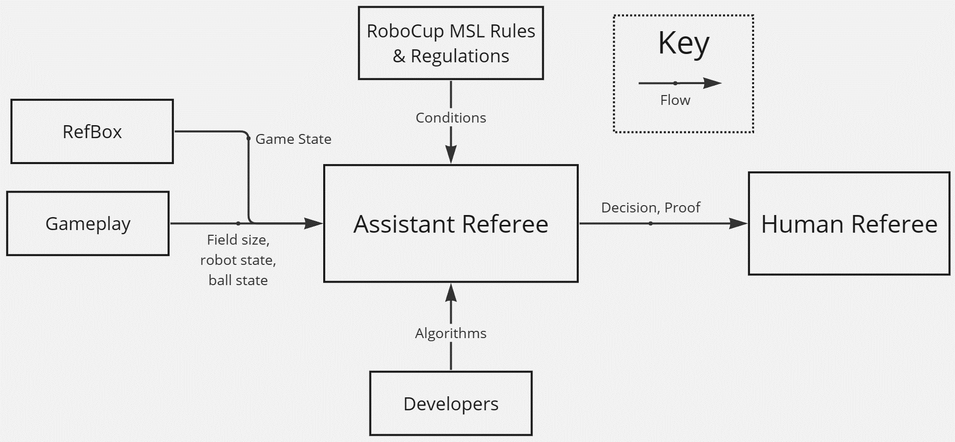
System Operational Diagram:
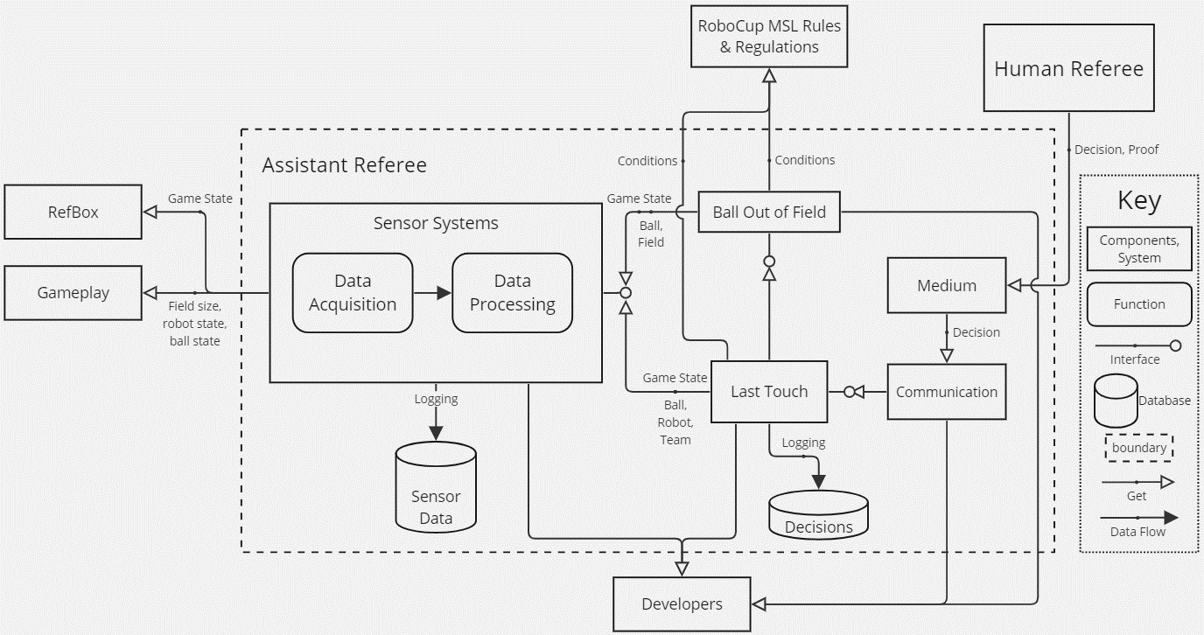

Validation
The validation method was described in the validation document. In this section, the system setup, testing procedure, statistical methods, and ground truth will be explained. The purpose of this document was to measure if the proposed system achieve the desired target.

Risk Management
The risks of the defined architecture were listed in the registers, and its detail can be referred in the Project Management Plan document.

Feasibility Study
The feasibility study has been documented in the feasibility document. As a summary, the chosen sensor was OptiTrack. More explanation can be found in the documentation.

Development Approach
Automation that brings consistency and enables a link between corporate a link between corporate office media. You will get a unity in communication media such as letters, offers and PowerPoint presentations, and you can be sure of the most up-to-date information and clear, clear, high-quality self-presentation. The association with your corporate design is also important. Often, making your work processes efficient and effective means digitising your work, but goes beyond

Work Breakdown Structure
The WBS serves as the roadmap, guiding us through the project's various stages and tasks with precision and clarity. By systematically breaking down the project into manageable components, it empowers our team to allocate resources effectively, track progress efficiently, and ensure alignment with our main goals. The Work Breakdown Structure (WBS) for our project is represented in the image below.

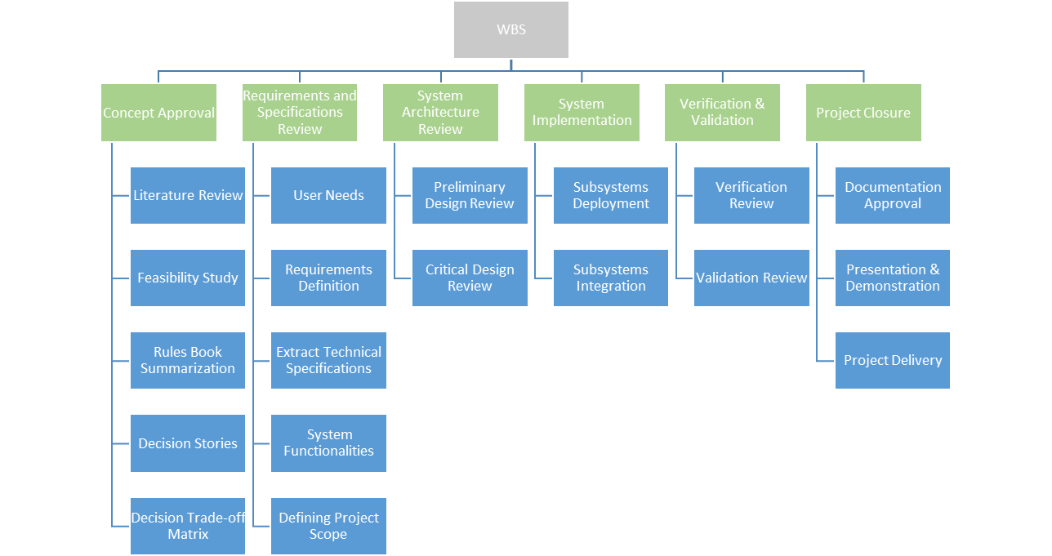

References

An example of a section header

An example of a subsection header
Automation that brings consistency and enables a link between corporate a link between corporate office media. You will get a unity in communication media such as letters, offers and PowerPoint presentations, and you can be sure of the most up-to-date information and clear, clear, high-quality self-presentation. The association with your corporate design is also important. Often, making your work processes efficient and effective means digitising your work, but goes beyond producing the right data.

An example of a paragraph title
Often, making your work processes efficient and effective means digitising your work, but goes beyond producing the right data. The association with your corporate design is also important. You will get a unity in communication media such as letters, offers and PowerPoint presentations, and you can be sure of the most up-to-date information and clear, clear, high-quality self-presentation. The association with your corporate design is also important.

- After all, it is these symbols that determine whether people recognise you
- the association with your corporate design is also important
- and you can be sure of the most up-to-date information
- The association with your corporate design is also important
- the association with your corporate design is also important
- and you can be sure of the most up-to-date information.

Automation that brings consistency and enables a link between corporate design and office media. In this way, you arrive at Unity in communication media such as letters, offers and PowerPoint presentations, and you can be sure of the most up-to-date information and clear, high-quality self-presentation. Often, making your work processes efficient and effective means digitising your work, but goes beyond producing the right data. The association with your corporate design is also important.

Which team touch the ball the last time.
              - Assign the team of all the robot (classification)
              - Find the positions of the robots and the ball.
              - Finding the robot who last touch the ball.
                - By the change in the ball vector, or
                - By applying Maching Learning (classification), or
                - By comparing the 3D space of the ball and the robot.

An example of a caption

An example of a caption

An example of a section header
Automation that brings consistency and enables a link between corporate a link between corporate office media. You will get a unity in communication media such as letters, offers and PowerPoint presentations, and you can be sure of the most up-to-date information and clear, clear, high-quality self-presentation. The association with your corporate design is also important. Often, making your work processes efficient and effective means digitising your work, but goes beyond producing the right data.

Example of a section header above a table
An example of a header in a table bar
An example of a table header | Table header | Table header | Table header | Table header
Getting a unity in communication media | means | digitalisation | of your work | presentation
But goes beyond producing the right data | relevance | tooling | design | counts
These symbols determine whether people recognise you | truthful | information | high-quality | recognition
The association with your corporate design is also important | careful | functional | association | statement
An example of a table header | Table header | Table header | Table header | Table header
Getting a unity in communication media | means | digitalisation | of your work | presentation
But goes beyond producing the right data | relevance | tooling | design | counts
The association with your corporate design is also important | careful | functional | association | statement
Getting a unity in communication media | means | digitalisation | of your work | presentation
But goes beyond producing the right data | relevance | tooling | design | counts
These symbols determine whether people recognise you | truthful | information | high-quality | recognition
The association with your corporate design is also important | careful | functional | association | statement
Getting a unity in communication media | means | digitalisation | of your work | presentation

An example of a header in a table bar
An example of a table header | Table header | Table header | Table header | Table header
Getting a unity in communication media | means | digitalisation | of your work | presentation
But goes beyond producing the right data | relevance | tooling | design | counts
These symbols determine whether people recognise you | truthful | information | high-quality | recognition
The association with your corporate design is also important | careful | functional | association | statement
Getting a unity in communication media | means | digitalisation | of your work | presentation
But goes beyond producing the right data | relevance | tooling | design | counts
These symbols determine whether people recognise you | truthful | information | high-quality | recognition
The association with your corporate design is also important | careful | functional | association | statement

An example of a footnote
Another example of a footnote
And another example An example of a caption Cause Idea Form Existence Needs, mission concepts Logical architecture Create instance

